PROJECT MANAGEMENT PLAN

***<Sustainable smart community>***

***Group <14>***

***<Sun Ruotong>***



**Planning Phase**

**Instructions**

**Document Purpose**

The Project Management Plan defines the project objective and scope as well as how it is executed, monitored, and controlled during the Delivery Stage.

**Who Produces This Document**

The assigned Project Manager produces the Project Management Plan in collaboration with the project team members and in consultation with the functional organizations involved in the managerial and technical processes described herein.

**Using this Template**

|  |
| --- |
| *<To create a Project Management Plan from this template, simply:*   1. *Replace the title on the cover page with the name of your project and the organization information.* 2. *Replace the <italicized text> in the document header with your project name and information.* 3. *Save your document with a filename that is in accordance with current document naming standards.* 4. *Update the filename in the document footer by right-clicking and selecting “edit footer”.* 5. *Complete the entire template. Each section contains abbreviated instructions, shown in italics, which can be removed once your document is finalized. Tables are also provided as a suggested layout for some of the information required.* 6. *Update the table of contents by right-clicking and selecting Update Field, then update entire table.* 7. *Note: Replace all* *the text between the less than/greater than symbols “<…>” with project specific statements.* 8. *Update all automatic fields (e.g. last save date and filename on title page, table of contents, filename in footer) by placing the cursor on the fields and pressing F9.* 9. *Delete this page when the Project Management Plan is complete.>* |

**Revision History**

| Version Number | Description | Date Modified | Author |
| --- | --- | --- | --- |
| 1.0 | Project Documentation Draft | 2024/05/22 | All team members |
| 2.0 | Development details requirements | 2024/05/23 | All team members |
| 2.1 | Add some missing technical requirements | 2024/05/25 | Front and back end leaders |
| 3.0 | Perfect typography | 2024/05/26 | All team members |
|  |  |  |  |
|  |  |  |  |

**Authority Signatures**

The Project Lead (Business Side) and the Project Manager agree to deliver the Delivery Stage of this project in accordance with this Project Management Plan and amend it periodically as project parameters change.

|  |  |  |  |
| --- | --- | --- | --- |
| Prepared by: | | | |
|  | Signature | | |
| Please print: | |  |  |
|  | Name | ID | Date |

|  |  |  |  |
| --- | --- | --- | --- |
| Approved by: | | | |
|  | | Signature | |
| Please print: |  |  |  |
|  | Name | Title | Date |

Table of Contents

1 Executive Summary 6

1.1 Problem and Motivation 6

1.2 Objectives 6

1.3 Success Criteria 6

2 Integration Management 7

2.1 Project Team Structure 7

2.2 Roles and Responsibilities 7

2.3 Change Management 8

2.3.1 Change Control 8

2.4 Project Close Out 8

3 Scope Management 8

3.1 Scope Statement 8

3.2 Requirements Management 10

3.2.1 Requirements Gather 10

3.2.2 Functional Requirement 10

3.2.3 Non-Functional Requirement 12

3.2.4 Domain Requirements 12

3.3 Project Deliverables 13

3.3.1 Work Activities 13

3.3.2 Constraints 15

3.3.3 Assumptions 16

3.3.4 Stakeholders 16

3.4 Validate Scope 17

3.5 Control Scope 17

4 Schedule Management 17

4.1 Milestones 17

4.2 Schedule Control 18

4.2.1 Project Schedule Network Diagram 18

4.2.2 Estimate Activity Duration 18

4.2.3 Gantt Chart 20

4.2.4 Critical Path Method 21

5 Cost Management 22

5.1.1 Estimation 23

5.1.2 Budget Allocation 23

5.1.3 Budget Control 23

6 QUALITY MANAGEMENT 24

6.1 Perform Quality Assurance 24

6.2 Quality Control 25

7 HUMAN RESOURCE MANAGEMENT 26

7.1 Human Resources Acquisition 26

7.2 Human Resources Development 26

7.3 Human Resources Management 27

8 COMMUNICA TIONS MANAGEMENT 28

8.1 Stakeholder Analysis 28

8.2 Project Reporting and Communication 29

9 Risk Management 30

9.1 Risk Management Plan 30

9.1.1 Methodology 30

9.1.2 Roles And Responsibilities 31

9.1.3 Budgeting 31

9.1.4 Time Management 31

9.1.5 Risk Categories 31

9.2 Risk Identification 31

9.3 Risk Analysis 32

Sensitive Analysis 32

9.4 Risk Control 33

9.4.1 Risk Reassessment 33

9.4.2 Variance and Trend Analysis 33

9.4.3 Reserve Analysis 33

9.4.4 Risk Audits 33

10 References 33

# Executive Summary

## Problem and Motivation

In the background of the urgent need for sustainable development, the realization of sustainablecommunities in Sustainable Development Goal 11 had become a major topic for Natural EdgeProperty Management Company. For example, Edge of Nature property Management Companyprovides some convenient facilities, but according to the survey, these facilities have extremelylow utilization and high carbon emissions, which is not in line with the concept of sustainabledevelopment. Therefore, in order to help Nature's Edge property management company solvethese problems, we developed a sustainable smart community website.

However, it is clear that the traditional model of community websites can not achieve the above goals, and in the increasingly complete service function of the various community platforms to seize the market. Therefore, the project needs to solve the following main problems: First, the platform should be compatible with the high-quality service functions of traditional community platforms and have relevant functions to help community users realize the concept of sustainable development; the other is to make the functions more innovative to attract platform users. Therefore, our projects will focus on functional integrity, security and stability to minimize site maintenance costs and improve project reliability.

## Objectives

By integrating an efficient resource management system, intelligent facility control and a user-friendly interface, the website will achieve the following:

1. User-friendly interface and intelligent AI assistant: Help new users learn to use the relevant functions of the platform more quickly and easily.

2. Promote sustainable development: Through the sustainable development guide, popularize the knowledge of community sustainable development, improve the utilization rate of community facilities, and reduce resource waste.

At the same time, the guide charts monitor the reduction of carbon emissions in the community and promote sustainable development.

3. Promote knowledge and employment: In addition to promoting sustainable communities, the recruitment module and community library module are added to the community platform to promote SDG4(Quality education) and SDG8(employment).

4. High service in traditional communities: Provide innovative service functions, enhance user experience, and attract more users to use the platform.

## Success Criteria

The following table states the quantitative and measurable objectives for this project.

|  |  |  |
| --- | --- | --- |
| serial number | quantitative and measurable objectives | judgment criteria |
| 1 | Page response time | No more than 1 seconds |
| 2 | Data loading time | No more than 1.5 seconds |
| 3 | Page error rate | Less than 1% |
| 4 | Troubleshooting User function exceptions | No more than 3 |
| 5 | system availability | More than 99% |
| 6 | security | More than 99% |

# Integration Management

Integration management refers to the process of ensuring that all aspects of a project are coordinated to achieve project goals. It is a key knowledge area in project management, covering all stages from project initiation to project closure. The core of integration management is to consider all aspects of the project comprehensively and ensure that different project elements work together seamlessly and communicate effectively.

## Direct and Manage Project

|  |  |  |  |
| --- | --- | --- | --- |
| Deliverable | Recipients | Delivery Date | Delivery Method |
| Analyze requirements with Dr. Catherine | Project Manager, Teammates | 2024/02/25 | Documents, diagram |
| Determine the software project architecture | Project Manager, Teammates | 2024/02/28 | Documents, diagram |
| Determine the software technology route | Project Manager, Teammates | 2024/03/02 | Documents, diagram |
| Final requirements documents | Project Manager, Project steering group | 2024/03/05 | Documents, diagram |
| System Design | Project Manager, Teammates | 2024/03/09 | Documents, diagram |
| Project charter | Project steering group | 2024/03/11 | Documents, diagram |
| Group proposal presentation | Project steering group | 2024/03/13 | Documents, video |
| Project management plan | Project steering group | 2024/03/16 | Documents, diagram |
| Front-end UI Design | Project Manager, Teammates | 2024/03/19 | Documents, diagram |
| Database Design | Project Manager, Teammates | 2024/03/21 | Documents, diagram |
| Bank-end Design | Project Manager, Teammates | 2024/03/23 | Documents, diagram |
| Interface Design | Project Manager, Teammates | 2024/03/25 | Documents, diagram |
| Front-end function Design | Project Manager, Teammates | 2024/03/27 | Documents, diagram |
| Mid-term demonstration video | Project steering group | 2024/04/01 | Documents, diagram |
| Front-end Codes | Project Manager, Teammates | 2024/05/10 | Package, Github URL |
| Back-end Codes | Project Manager, Teammates | 2024/05/13 | Package, Github URL |
| Cloud-based server deployment | Project Manager,  Teammates | 2024/05/16 | Package, URL |
| User Documents | Project steering group,  Senior Users | 2024/05/20 | Documents, diagram |
| System Documents | Project steering group,  Senior Users | 2024/05/24 | Documents, diagram |
| System Test Report | Project steering group,  Senior Users | 2024/05/26 | Documents, diagram |
| Final project | Project Manager,  Teammates | 2024/06/01 | Package, Github URL |
| Final demonstration video | Project steering group | 2024/06/03 | Documents, video |
| Final report | Project steering group | 2024/06/07 | Documents, Diagram |

## Project Team Structure

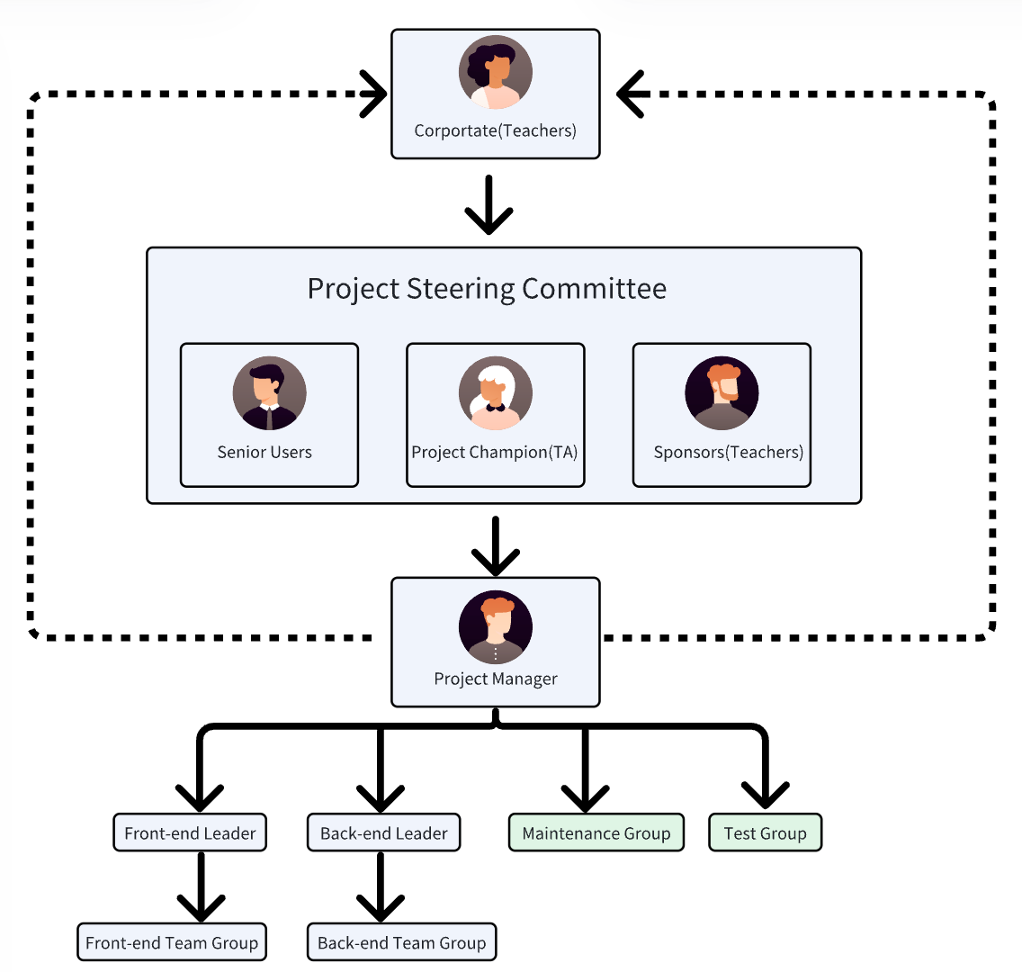

## Roles and Responsibilities

|  |  |  |  |
| --- | --- | --- | --- |
| Project Position | Name | Responsibilities | External resource |
| Corporate/Programmer Committee | Dr. Catherine Mooney | Representing the owner of the property management company | Tool: Gmail, class |
| Senior User | Dr. Catherine Mooney, TA, Other Groups | Test our project and rate our project presentation | Tool: class, excel, document |
| Project Manager | Sun Ruotong | Responsible for managing project progress, recording contributions, assigning tasks, and organizing front-end and back-end joint debugging | Tool: Wechat, Github |
| Front-end A Leader | Wang Shizheng | Design and implement product-related pages | Tool: VsCode, Github, React, NextJs, Tailwind CSS |
| Front-end B Leader | Qi Te | Design and implement pages related to users | Tool: VsCode, Github, React, NextJs, Tailwind CSS |
| Back-end Leader | Liu Huiyang | Design and implement all backend functionality | Tool: VsCode, Github, React, flask, python |
| Test Manager | Zhang Juncheng | Responsible for project management plan testing, functional testing and performance testing | Tool: VsCode, Overleaf, Latex |
| Maintenance Manager | Liu Xinran | Responsible for version tracking, and maintenance during operation | Tool: VsCode, Overleaf, Latex |

## Change Management

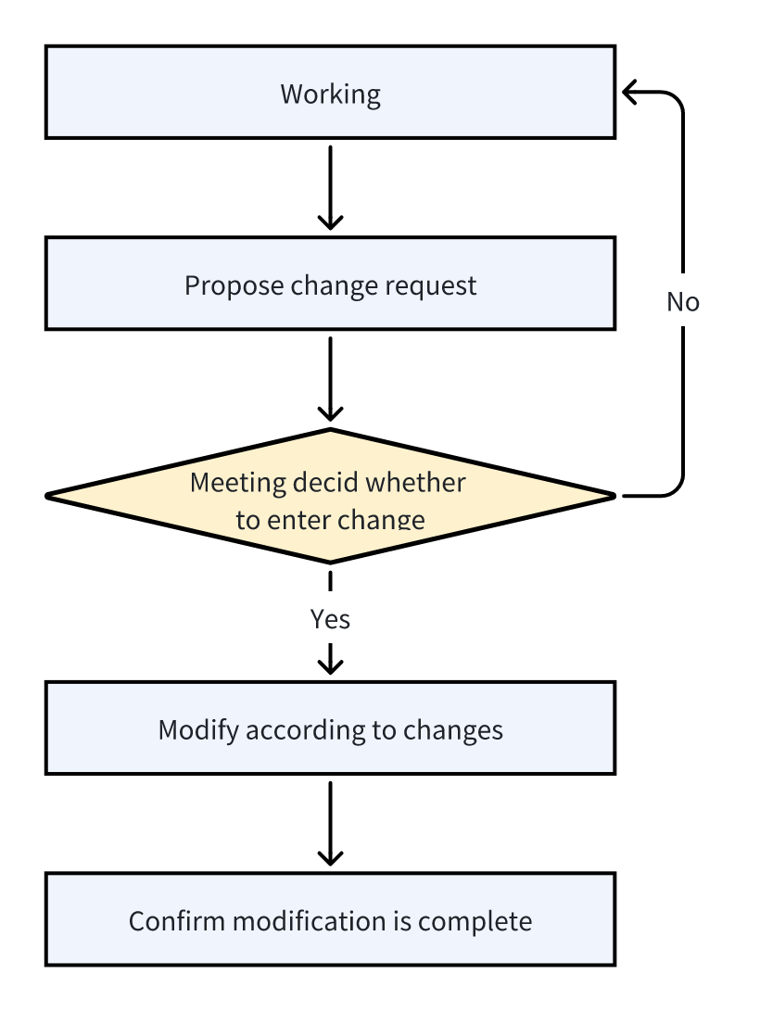

* Propose change request
  + Roles: Record areas found during work that may need modification
  + Reponsibilities: The project maintenance team is responsible for recording and processing these requests, completing the details of the requests, and ensuring that all requests can be queried.
  + Tools: Lark to-do panel, Lark document GitHub code review
  + Techniques: Can record periodic meetings or code submissions, and record the content, date, version, etc. of the change request
  + Reporting: Record in the change log
* Meeting decid whether to enter change
  + Roles: According to the specific reasons for the modification request, confirm the necessity of the modification and decide whether to continue the execution
  + Reponsibilities: The project manager will organize and be responsible for this process and ensure that relevant members are involved in the decision-making process.
  + Tools: Lark meeting, Tencent meeting, zoom or offline meeting
  + Techniques: A detailed description of the reasons for the request helps the relevant responsible person understand the impact of the change and decide whether it is worth making the change.
  + Reporting: Record in the modification log and explain the reason
* Modify according to changes
  + Roles: Executing changes
  + Reponsibilities: Front-end developers and back-end developers are responsible for this content and modify the project according to specific change requirements.
  + Tools: GitHub and code editors such as vscode and pycharm
  + Techniques: The code submission process should record the corresponding change log, and also record the corresponding code part in the log
  + Reporting: Modification log and code submission notes
* Confirm modification is complete
  + Roles: Confirm that the modification is completed and meets the expected changes
  + Reponsibilities: The project manager needs to confirm the completion of the change request based on the log and code to ensure the completion of the change
  + Tools: GitHub, Lark Documents
  + Techniques: Analyze the modified process and check if there is a better solution
  + Reporting: Report change result

### Change Control

* Change governance
  + For changes, we divide them into external needs and internal needs
  + External requirements refer to functional or non-functional changes caused by misunderstanding of requirements.
  + Internal requirements are considered to be logical problems discovered during the development or testing process, logical conflicts that were not discovered in time during the design phase.
* Change identification and request management
  + The change must first determine the cause of the change, and then decide on the subsequent treatment plan based on the cause.
  + Changes also need to be confirmed in terms of scope, human resources involved, time cost, project quality, etc.
  + Each change must be reviewed and confirmed to ensure that the overall project objectives are not affected
* Impact analysis
  + It is necessary to analyze the time, manpower, resources, cost, etc. brought about by each change, and the effect of the change should also be considered.
  + Changes and major tasks need to be prioritized, and the priority of each other should be determined based on urgency.
* Change approval process
  + The project manager needs to organize a meeting to decide whether to proceed with the change based on the analysis results. This decision also requires discussion among project participants and confirmation based on the majority opinion.
  + If the decision is made to implement the change, the project manager will need to arrange the follow-up plan.
* Change tracking
  + For each change, it is necessary to record it in detail as originally planned, and at the same time ensure that each change can maintain a certain order or version to support subsequent progress tracking.

## Project Close Out

1. Staff reassignment plan
   1. When the project is completed, some members who have a more complete understanding of the project will be selected from the project participants, and they will continue to work for the subsequent maintenance of the project. For example, fix bugs that occur during the use of the project, or perform non-functional optimization on the project.
   2. The remaining project participants will be disbanded and added as available human resources to upcoming or ongoing projects.These people may continue to work in different project teams based on their different skills.
2. Archiving project materials
   1. After completing the project, project members will organize and archive all materials, including all documents, modification records, logs, periodic reports, and other content generated during the development process.
   2. After the sorting is completed, each document needs to be reviewed and verified to ensure its authenticity and integrity. For example, whether there is any illegal modification or accidental loss.
3. Post-mortem debriefings of project personnel
   1. After the project is finally completed, each member involved in the project must report on the project, which can be done offline, online, or in written form.
   2. The report content can be anything the members want to express, such as what they have learned from the project, their feelings about the project, or the unpleasantness they feel during the project. This will be conducive to the subsequent improvement and optimization of management methods.
   3. Of course, project members who have completed the project well will be rewarded.
4. Final Report
   1. The final report will confirm the completion of the project, whether it was successful, whether it was recognized by stakeholders, and also summarize the budget, timeline, change history, etc.
   2. When a project is successful, you need to summarize the possible reasons for success and record the relevant management plans. When a project fails, you need to pay attention to the reasons for failure and trace the root causes. In the end, you need to summarize what you learned from the project.

# Scope Management

## Scope Statement

Project Scope Management primarily focuses on defining and controlling what is included and excluded in the project, as well as the necessary processes to ensure that all the required work is encompassed for the successful completion of the project.

| Activities In Scope | Activities Out of Scope |
| --- | --- |
| Activities In Scope | Activities Out of Scope |
| Normal users should,  - Receive the latest announcement popup  **-** View all announcements  **-** View all sustainability guidelines and their detailed pages  **-** View all e-books  **-** Specify book search  **-** E-book download  **-** Consult AI customer service  **-** Customize your personal information  **-** Monitor your own use of living resources  **-** View and subscribe to community services  **-** Apply through the community recruitment platform  **-** Booking community service | Users cannot,   * Communicate with other users. * Cancel their community service reservation orders without communicating with administrator. * Modify their order status. * Modify the type of daily resources in the chart. * Revoke resume without communicating with administrator. |
| Administrators should,  - Add, delete, and modify community announcements  **-** Manage and add new administrators  **-** Add, delete, modify sustainability guidelines and their detail pages  **-** Add, delete, modify electronic books  **-** Add, delete, modify community services  **-** View the community service booked by the user and its related specific information  **-** Recruitment through community recruitment platforms  **-** View recruiter information  **-** Review (accept or reject) candidates | Administrator cannot,   * Delete all elements of the website. * Place orders. |
| Enterprises should,   * Recruitment through community recruitment platforms * View recruiter information * Review (accept or reject) candidates | Enterprises cannot,   * Delete all elements of the website |
| The system should,   * Provide a clear layout for customers * Provide a search engine for users * Light and dark theme swtich * Provide user test reports * High performance fast response. * Provide AI customer service * Be deployed on a server. * Consider security, availability, maintainability, and extensibility |  |
| The database should,   * Have a backup to avoid one-point failure * Easy to extend * Define milestones * Define development tools: language, environment, devices * Code implementation * Develop test plan * Server Deployment |  |

## Requirements Management

### Requirements Gather

Brainstorming

First, we conduct a brainstorming session to gather as many ideas and requirements as possible from all stakeholders. This is a collaborative process where team members freely share their thoughts, concerns, and suggestions. A technique used to generate and collect multiple ideas related to project and product requirements.

Affinity Diagram

Next, we use an affinity diagram to organize and categorize the collected ideas. During this phase, the team reviews all the brainstormed requirements and groups similar items together. This helps in identifying common themes and areas of focus. It allows large numbers of ideas to be classified into groups for review and analysis.

Plurality Voting

Finally, we employ plurality voting to make decisions on the categorized requirements. Team members vote on the categories or individual requirements they believe are most critical or beneficial to the project. A decision that is reached whereby the largest block in a group decides, even if a majority is not achieved.

### Functional Requirement

**Community education resource module:**

Available to owner users

E-book data: Entry of valuable, complete, e-book format books.

Classification: E-books are classified by keywords (tags), and books are sorted by time under the classification.

Search function: Books can be searched according to some fields of the title.

Book download: Books that users want to browse can be downloaded and viewed offline.

Bookmarks: Users can record which page of the e-book they read and jump directly to it.

Manual customer service search title: Through the user's description of the book, recommend the book in the electronic library to the user.

Property users can add and delete books and modify book information (keywords/tags).

**User registration and login system module:**

Open the page first display the home page.

Registration information: user name, password, email, address information, address information proof materials, can only be registered owner users, property users need to unlock resources after audit, recruitment.

Login information: Username / Email / phone, password.

The same set of login system, but according to the user identity display different homepage.

Users can add an avatar.

Anonymous users can view guides, services, education, announcements.

Owner users can view guides, services, education, announcements, resources (subject to review), jobs (subject to review).

Business users can view guides, services, education, announcements, recruitment; Ability to edit, post and delete job postings.

Property users can view guides, services, education, announcements, recruitment; Can edit, publish, delete announcements, education, guides, services, books; Review the recruitment of corporate users; Review the owner user's address information supporting materials.

AI assistant.

**Owner resource management module:**

Owner information: account number, registrant, contact information.

Owner's resource classification: water consumption, electricity consumption, gas consumption; Data are aggregated on a monthly basis (heating costs in winter; Property charges).

The card shows the consumption of the year (e.g. water, electricity).

Use the chart library to display a line chart throughout the year (showing changes in usage).

Comparison with community per household (or "green" standard) data (horizontal comparison).

The user sets the alarm threshold. If the alarm exceeds the threshold, the platform generates an alarm.

Notification: Pop-up window will be displayed every time you enter the page.

**Community recruitment platform module:**

Can view all the job postings.

Click Publish information to view the full text, you can click the send resume function.

Fill in the name, contact information and resume file can be sent (also sent to the corporate user's email address).

Business users can filter published (not approved), pending review, received delivery.

A business user editing a posted job or an unapproved job requires a property review.

**Community announcement module:**

Click to view All Announcements to view all existing announcements in the history (announcement title, click to enter the page to view the announcement details).

The property can edit the configuration to delete the content of the pushed announcement and update the push status of the existing announcement.

**Other auxiliary functions:**

Switch between dark and light themes, English/Chinese switching, Page switching animation

### Non-Functional Requirement

**Performance requirement:**

The system response time should be controlled within 2 seconds, and for complex queries and other operations, the response time should not exceed 5 seconds.

**Reliability requirement:**

The system should have high availability to ensure that the service availability time reaches more than 99.99%. And the system should have fault tolerance, in the event of failure can be quickly recovered, and does not affect the normal operation of the system.

**Security requirement:**

The system should have a strict user authentication mechanism to ensure the legitimacy and security of user identity. The system shall encrypt and store and transmit sensitive data to protect users' private information from being leaked.

**Maintainability requirement:**

The system should have good maintainability and be easy to update and expand. The system should provide comprehensive logging and error reporting functions to facilitate the developer to troubleshoot and repair.

**Availability requirement:**

The system should have a good user interface design, simple and clear, easy to use. The system should have good documentation and help functions to facilitate users to query and learn the use of the system.

**Operating cost requirement:**

For the website construction cost does not exceed the budget, for the later profit requirements do not exceed the maintenance and operating costs.

**Scalability requirement：**

The system should have good scalability, and can easily integrate and expand new functional modules. The system should support the needs of multiple languages and regions, and be able to adapt to users in different regions and language environments.

### Domain Requirements

This type of requirements is characteristic of a particular category or domain of projects.

In our project, this mainly involves community management and job recruitment for residents.

**Sustainability guide module:**

Input some household (electricity, water, household waste, etc.), community, travel methods and other aspects of sustainable development guidelines, list the content, click on the full text can be seen, property users can publish new guidelines, property users can delete and edit the guidelines.

**Community service inquiry module:**

Map query content: fitness equipment, supermarket convenience store, fitness gym swimming pool, elderly activity center, children's playground, photo studio Photocopying studio, elderly health center.

Map display: Different facilities are displayed on the map with different signs, and users can choose to see only a certain type or all through the label, and click on a specific place to display the panorama.

On-site service types: water delivery, newspaper subscription, water and electricity maintenance.

On-site service appointment: owner information, on-site time, service type (water and electricity) maintenance: maintenance type, specific problems.

## Project Deliverables

| Deliverable | Recipients | Delivery Date | Delivery Method |
| --- | --- | --- | --- |
| Requirement document | Project team members | 2024-04-12 | e-mail |
| UI design | Liu Xinran | 2024-04-26 | e-mail |
| Flowchart and ER diagram | Sun Ruotong | 2024-04-26 | e-mail |
| Interface documentation | Project team members | 2024-05-01 | e-mail |
| Front-end code | Project team members | 2024-05-26 | git |
| Back-end code | Project team members | 2024-05-26 | git |
| Deployed website | Project team members | 2024-06-01 | UCD VM |

### Work Activities

#### Work Breakdown Structure

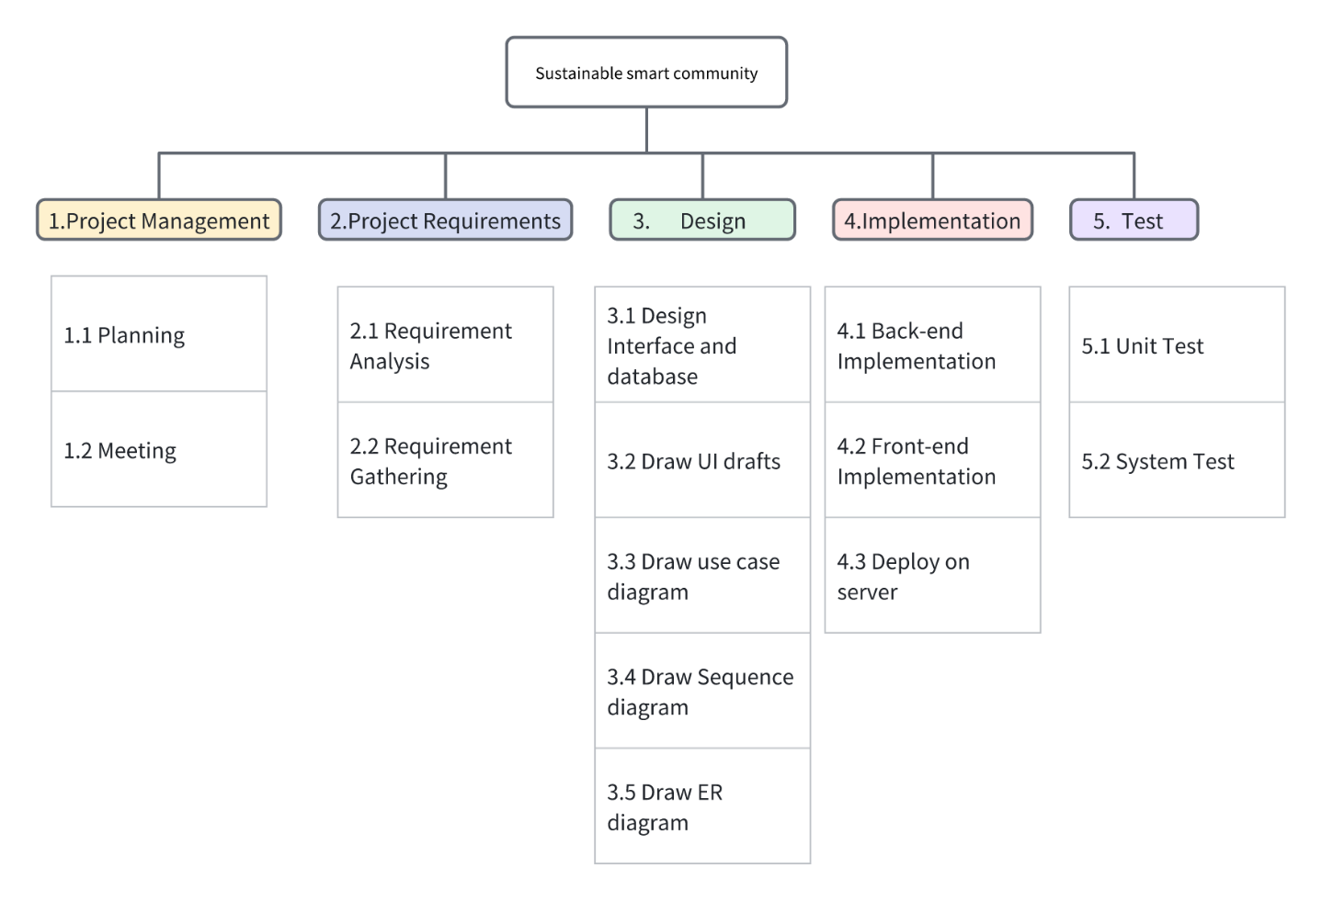

#### Work Breakdown Structure Dictionary

|  |  |  |
| --- | --- | --- |
| WBS Code | Title | Notes |
| 1 | 1 Project Management |  |
| 1.1 | 1.1 Planning | Design team project plan and division of labor |
| 1.2 | 1.2 Meeting | Meeting to inform all members |
| 2 | 2 Product Requirement |  |
| 2.1 | 2.1 Requirement Analysis |  |
| 2.2 | 2.2 Requirement Gathering |  |
| 3 | 3 Design |  |
| 3.1 | 3.1 Design Interface and database |  |
| 3.2 | 3.2 Draw UI drafts |  |
| 3.3 | 3.3 Draw use-case diagram |  |
| 3.4 | 3.4 Draw Sequence diagram |  |
| 3.5 | 3.5 Draw ER diagram |  |
| 4 | 4 Implemention |  |
| 4.1 | 4.1 Backend Implementation |  |
| 4.2 | 4.2 Frontend Implementation |  |
| 4.3 | 4.3 Deploy on server | Deploy on UCD domain name |
| 5 | 5 Test |  |
| 5.1 | 5.1 Unit test | Can the interface be implemented through mock data testing |
| 5.2 | 5.2 System test | Can the functionality of the testing project be implemented |

### Constraints

**-** Requirements will keep changing during the development process.

**-** Team members’ abilities do not at the same level.

**-** The project needs to be deployed on a server

**-** UI after the draft by the front-end to confirm the implementation

**-** MySQL is used as the database, it is necessary to determine the

database architecture before the project starts and maintain the stability of the architecture during the project cycle.

**-** Any back-end logic changes or API updates must be kept up to date

with API documentation and notified to the front-end team.

* The privacy and security of residents in the community need to be protected, and only users with sufficient permissions can view them.
* The project should be delivered by 15th June, 2024
* The maximum funding available for the project is $120,000.
* The project should complete all milestones in time according to the milestones schedule.

### Assumptions

* The developer and the client have agreed on the project design requirements and details, which will remain largely unchanged during the development.

**-** All team members are familiar with the version management tool Git.

**-** All team members are familiar with web development techniques, HTML, CSS, JavaScript, React, Nextjs, Ajax(Axios).

**-** All team members are familiar with relevant tools such as Chrome, Vscode.

**-** All team members are familiar with the front-end separation pattern.

**-** Team members can understand and implement RESTful API design.

**-** All team members have experience with MySQL.

**-** All members are familiar with the Python programming language and its

common libraries.

**-** The back-end development team can handle cross-domain resource

sharing (CORS) issues, ensuring smooth communication between the

front and back ends.

* All team members adhere to the Team Agreement and accept the designated rewards and penalties
* Ensure effective interaction between team members to solve problems.

### Stakeholders

**-** Project Company

**-** Project sponsor: Dr. Catherine

**-** Project Team

**-** Project manager: Ruotong Sun

**-** Other Project Team Members: Shizheng Wang, Huiyang Liu, Xinran Liu, Te Qi, Juncheng Zhang

**-** Program Team of Software product department of property management

**-** Program manager

**-** Other Program Team Members

**-** Ohter Company Members

**-**  Customers/Users

**-** Nature's Edge property Management

**-**  Enterprises cooperating with community property management

**-**  Community residents

**-** External visiting users

**-** Sellers/Business Partners

## Validate Scope

This project will be formally checked by the project sponsor Dr. Catherine Mooney, and the sponsor will confirm the quality of our deliverables and verify whether our deliverables meet the requirements of users.

## Control Scope

- Scope Creep

To allow the scope baseline to be maintained throughout the project, the change is to be approved by the sponsors and the group’s ability to modify the scope will be assessed.

- Gold Plating

Team members will hold weekly meetings to review and revise the project scope. In cases where scope modifications are necessary, they will report to Dr. Catherine Mooney to prevent any deviations or discrepancies from the customer’s original requirements.

# Schedule Management

In this section, we present milestones, Gantt charts, to record the progress of our project and describe how time is managed throughout the delivery phase of the project.

## Milestones

| **Description** | **Forecast Date** | **Gate / Approval** |
| --- | --- | --- |
| Design project requirements and function points | 2024/3/10 | 2024/3/11 |
| Finish UI drafts, check function maps | 2024/3/14 | 2024/3/14 |
| Architecture, interface and database design | 2024/3/20 | 2024/3/22 |
| Database Integration Finish | 2024/4/1 | 2024/4/2 |
| Front-end page structure development Finish | 2024/4/15 | 2024/4/15 |
| Back-end functions development Finish | 2024/4/25 | 2024/4/25 |
| Final system finish | 2024/5/17 | 2024/5/18 |
| System testing | 2024/5/24 | 2024/5/25 |
| Software product release Finish | 2024/6/2 | 2024/6/2 |

## Schedule Control

### Project Schedule Network Diagram

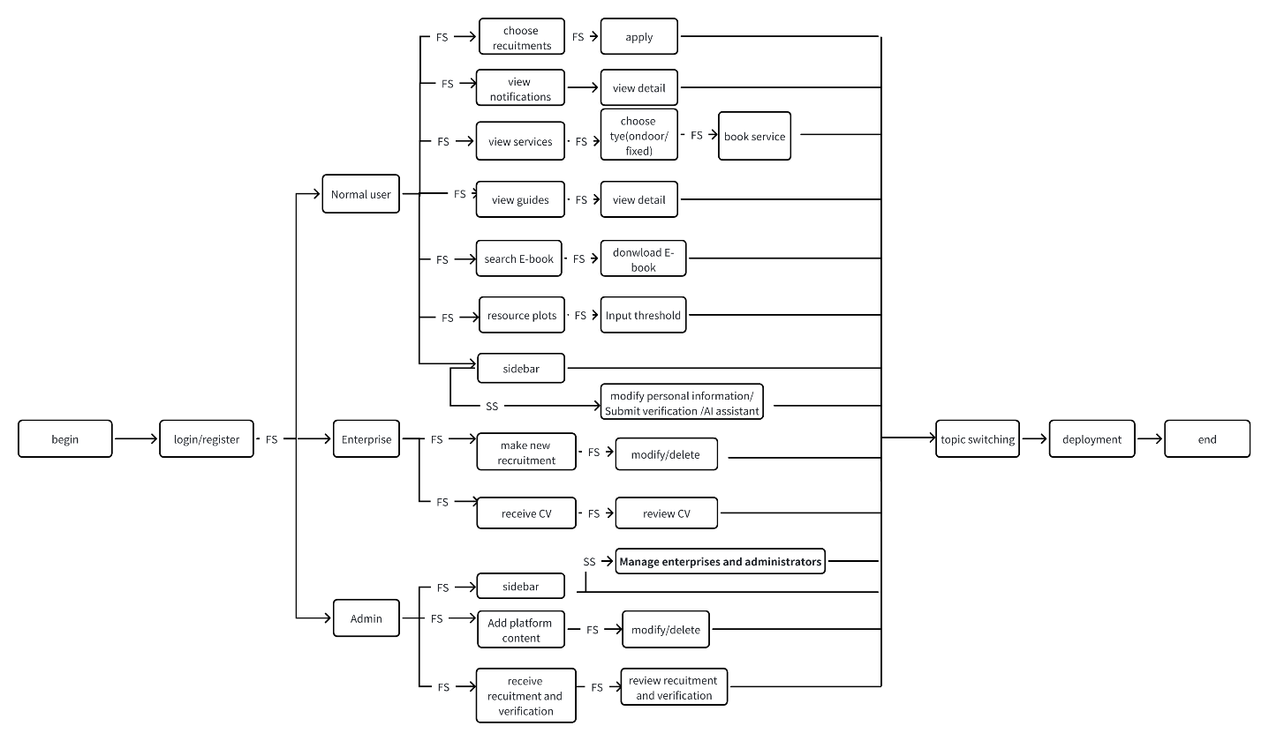

### Estimate Activity Duration

We will use the following formula to calculate the estimate for each event:

|  |  |  |  |  |
| --- | --- | --- | --- | --- |
| Name | tO(optimistic) | tM (most likely) | tP (Pessimistic) | tE(evaluation) |
| Login/Register | 2 | 3 | 4 | 3 |
| Normal user | 1 | 2 | 3 | 2 |
| Enterprise | 1 | 2 | 3 | 2 |
| Admin | 1 | 2 | 3 | 2 |
| View guides | 1 | 2 | 3 | 2 |
| View notifications | 1 | 2 | 3 | 2 |
| View services | 2 | 3 | 4 | 3 |
| Choose type(fixed/ondoor) | 1 | 2 | 3 | 2 |
| Book service | 2 | 4 | 5 | 3.8 |
| View guide detail | 1 | 2 | 3 | 2 |
| View notification detail | 1 | 2 | 3 | 2 |
| Search E-book | 5 | 6 | 9 | 6.3 |
| Download E-book | 4 | 6 | 10 | 6.3 |
| Resource plots | 10 | 12 | 15 | 12.1 |
| Input threshold | 3 | 4 | 5 | 4 |
| Choose recruitments | 3 | 4 | 5 | 4 |
| apply | 3 | 4 | 5 | 4 |
| Make new recruitment | 2 | 3 | 4 | 3 |
| Modify/delete recruitment | 2 | 3 | 4 | 3 |
| Receive CV | 2 | 3 | 4 | 3 |
| Review CV | 1 | 2 | 3 | 2 |
| Sidebar(Normal user and enterprise) | 1 | 2 | 3 | 2 |
| modify personal information/Submit verification /AI assistant | 15 | 18 | 21 | 18 |
| Sidebar(admin) | 1 | 2 | 3 | 2 |
| Manage enterprises and administrators | 2 | 3 | 4 | 3 |
| Add platform content | 5 | 7 | 8 | 6.8 |
| Modify/delete content | 2 | 3 | 4 | 3 |
| Receive recruitment and verification | 3 | 4 | 6 | 3.5 |
| Review recruitment and verification | 2 | 3 | 4 | 3 |
| Topic switching | 3 | 4 | 5 | 4 |
| Deployment | 1 | 2 | 3 | 2 |

### Gantt Chart

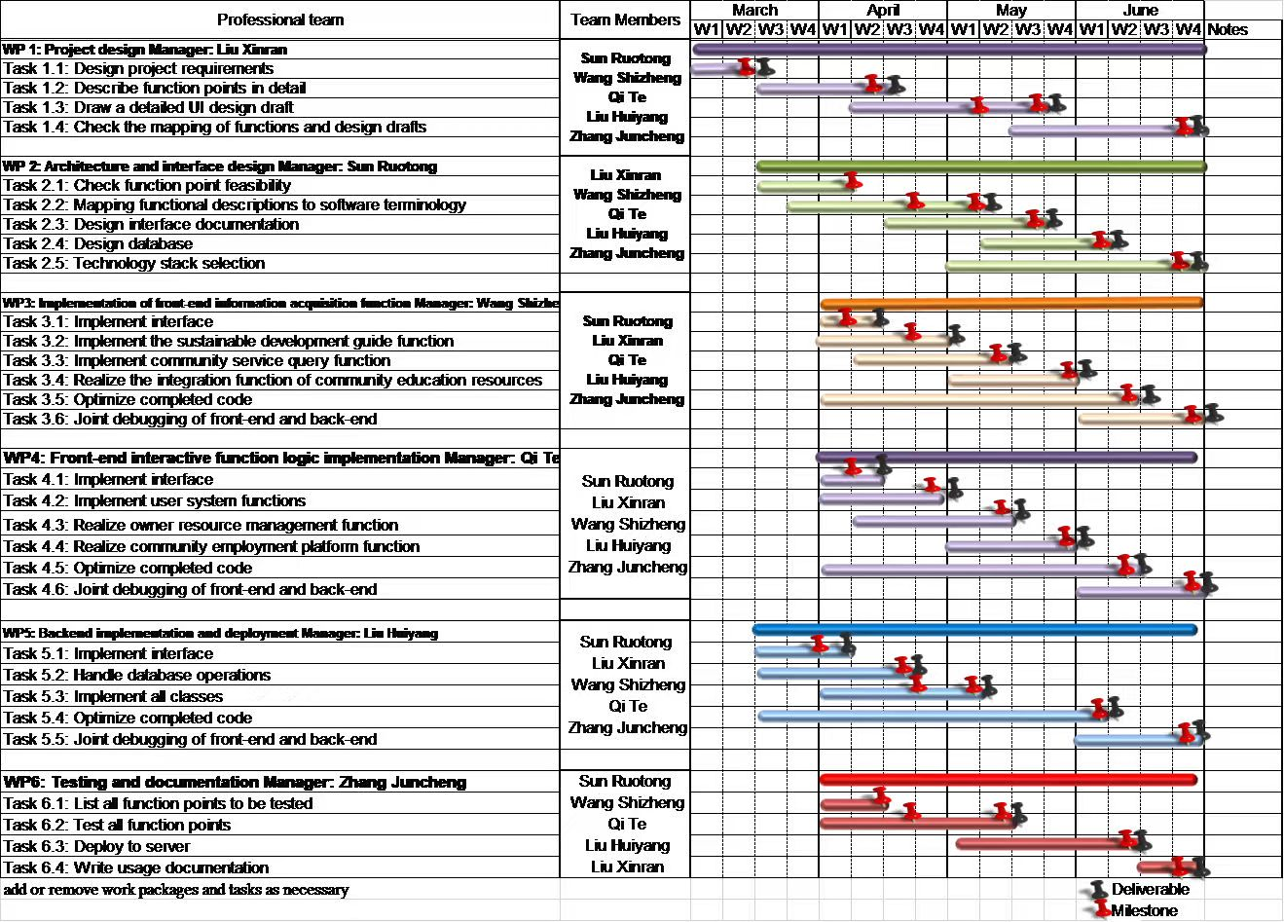

### Critical Path Method

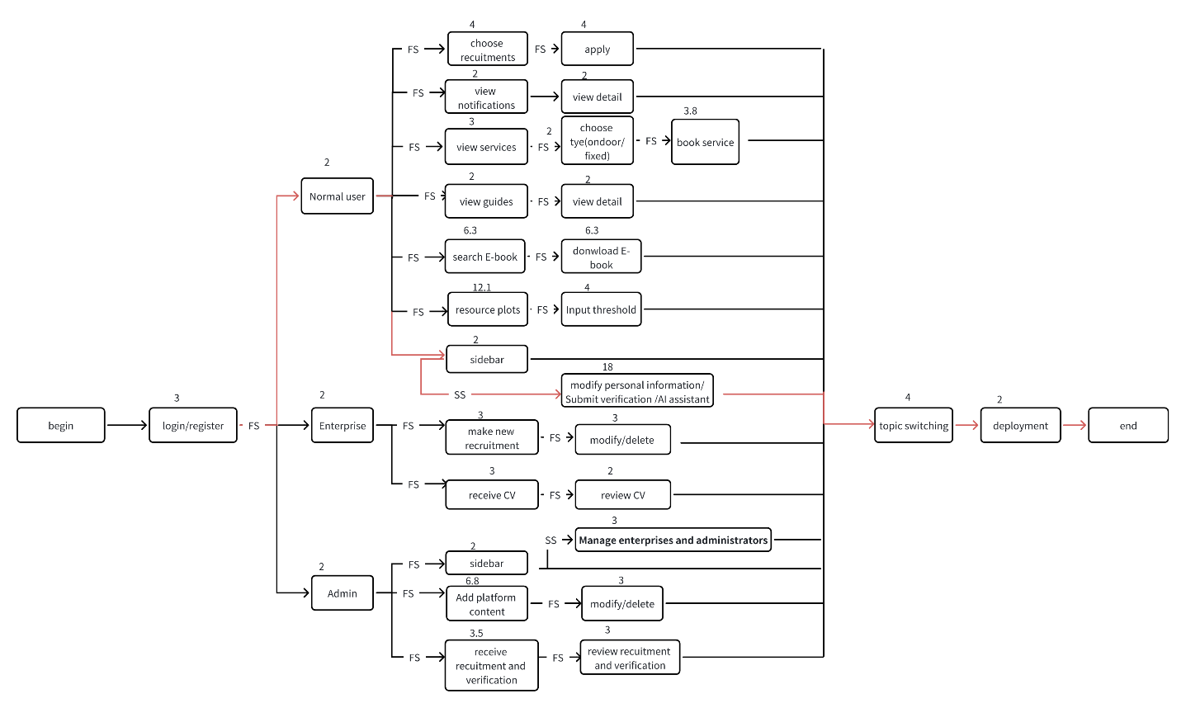

|  |  |
| --- | --- |
| Name | float |
| Login/Register | 0 |
| Normal user | 0 |
| Enterprise | 14 |
| Admin | 6.2 |
| View guides | 16 |
| View notifications | 16 |
| View services | 11.2 |
| Choose type(fixed/ondoor) | 11.2 |
| Book service | 11.2 |
| View guide detail | 16 |
| View notification detail | 16 |
| Search E-book | 7.4 |
| Download E-book | 7.4 |
| Resource plots | 3.9 |
| Input threshold | 3.9 |
| Choose recruitments | 12 |
| apply | 12 |
| Make new recruitment | 14 |
| Modify/delete recruitment | 14 |
| Receive CV | 15 |
| Review CV | 15 |
| Sidebar(Normal user and enterprise) | 0 |
| modify personal information/Submit verification /AI assistant | 0 |
| Sidebar(admin) | 15 |
| Manage enterprises and administrators | 15 |
| Add platform content | 6.2 |
| Modify/delete content | 6.2 |
| Receive recruitment and verification | 13.5 |
| Review recruitment and verification | 13.5 |
| Topic switching | 0 |
| Deployment | 0 |

# Cost Management

<*Describe how cost will be managed throughout the Delivery Stage of this project. This should include processes that will be used to develop the budget, roles and responsibilities, tools and techniques and reporting.>*

### Estimation

<Describes how project estimates will be prepared, including:

* The methods, tools, and techniques that will be used to estimate project size, effort, cost, schedule, and critical computer resource requirements.
* The timing of the estimates.
* Who will participate in the estimation process.
* How the estimates will be documented, reviewed, and reported.

You can include the actual estimates in this section or they can be stored elsewhere. For each estimate made, document the estimation method used, the assumptions made, and the confidence level for the estimate. Describe the rationale behind contingency buffers incorporated into estimates. Specify the methods to be used periodically to re-estimate the cost, time, and resources needed to complete the project.>

### Budget Allocation

<Provide a detailed breakdown of necessary resource budgets for each of the major work activities in the work breakdown structure. The activity budget should include the estimated cost for activity personnel and may include, as appropriate, costs for factors such as travel, meetings, computing resources, tools, special testing and simulation facilities, and administrative support. A separate line item should be provided for each type of resource in each activity budget. The work activity budget may be developed using a spreadsheet and presented in tabular form.>

### Budget Control

<Specify the control mechanisms to be used to measure the cost of work completed, compare planned cost to budgeted cost, and implement corrective action when actual cost does not conform to budgeted cost. The budget control plan should specify the intervals at which cost reporting will be done and the methods and tools that will be used to manage the budget. The budget plan should include frequent milestones that can be assessed for achievement using objective indicators to assess the scope and quality of work products completed at those milestones.

# QUALITY MANAGEMENT

Project quality management includes the processes and activities of the executive organization, which determine the quality policy, objectives and responsibilities, so that the project can meet its needs. Project quality management is committed to ensuring that project requirements (including product requirements) are met and verified.

## Perform Quality Assurance

Quality assurance refers to all planned, systematic activities carried out in a quality management system and verified as needed to give people confidence that a product or service will meet quality requirements. Quality assurance is the part of quality management that seeks to provide confidence that quality requirements will be met. Performing quality assurance is the process of reviewing quality requirements and quality control measurements to ensure that appropriate quality standards and operational definitions are used. Its main goal is to check for defects at the semi-finished stage of implementation, to prevent defects through a planning process.

|  |  |  |  |  |
| --- | --- | --- | --- | --- |
| Project Process | Project Quality Standard | Quality Assurance Activity | Frequency | Responsible |
| Develop project charter | Meet all requirements and have an appropriate estimate for the entire project | Update the project charter immediately and notify the client if there are any changes | Each project phase | Project manager |
| Execute and control project | Implement the required functionality on time and within the budget | Review the following project activities: quality, communication, and project schedule. | weekly | Project manager and the whole team |
| Approve each project stage | Controllable and in line with the actual situation, without too much deviation from the expected situation | Respond to change requests and monitor completion of each phase. | Every time delivery | The whole team |
| System document and user document | Provide detailed and clear documentation and introduce the project's functional usage and project development process | Audit document content | When delivering the project | The whole team |
| Review software development practices of software application | Delivered results that fully met requirements and were delivered on time and within budget | Peer review of software requirements specification | When delivering the project | The whole team |

## Quality Control

Quality control is the process of monitoring and recording the results of quality activities to evaluate performance and recommend necessary changes. During project execution and closure, management plans should be used to formally demonstrate with reliable data that acceptance criteria have been met.

|  |  |  |  |
| --- | --- | --- | --- |
| Project Deliverable | Deliverable Quality Standards / Completeness and Correctness Criteria | Quality Control Activity | Frequency/Interval |
| The whole website | Meet all requirements and have an appropriate estimate for the entire project | Audited by the Core team.  Audited by Review team, Audited by experts and volunteers. | Weekly and every milestone |
| PPT and presentation video | Implement the required functionality on time and within the budget | Review the following project activities: quality, communication, and project schedule. | The delivery phase |
| Web application related documents | Controllable and in line with the actual situation, without too much deviation from the expected situation | Respond to change requests and monitor completion of each phase. | Weekly and delivery phases or when stakeholders want |

# HUMAN RESOURCE MANAGEMENT

Human resource management is to organize team members and give full play to the role of each member to complete the project tasks together. Team members may have different technical strengths and different responsibilities. They will complete different tasks to promote the steady progress of the project and achieve.

## Human Resources Acquisition

|  |  |  |  |  |  |  |
| --- | --- | --- | --- | --- | --- | --- |
| RACI Charter | Staff | | | | | |
| Activity | Sun Ruotong | Liu Xinran | Wang Shizheng | Liu Huiyang | Qi te | Zhang Juncheng |
| Collect Requirements | I | R | C | C | I | I |
| Budget Management | A | R | I | I | I | I |
| Submit change request | R | I | A | I | I | I |
| Quality Supervision | A | I | I | C | I | R |
| Develop test plan | I | A | I | I | C | R |
| Develop Documents | I | I | R | I | A | C |
| Final Report | C | I | I | I | R | A |

## Human Resources Development

**Pre Project Training**

* **Pre Project Training**
* Before the start of the project, team members need to learn to use the two systems, Overleaf and GitLab, which will be used in the project cooperation. UI design members need to learn to use Figma.
* Team members need to agree on the way of communication among themselves and establish a schedule for daily meetings. This ensures clear and consistent communication throughout the project.
* **In-Project Training**
* During the project, provide continuous communication to address any emerging skill gaps or new tools required. This ensures that team members stay proficient and adaptable to any changes.
* Conduct regular workshops to address challenges encountered during the project. These sessions can foster collaborative problem-solving and innovation.
* Assign experienced team members as mentors to provide guidance and support to less experienced colleagues. This promotes knowledge sharing and skill development within the team.
* **Ground Rules**
* Establish a clear code of conduct for team interactions, including respect, professionalism, and inclusivity. This helps maintain a positive and productive team environment.
* Define procedures for resolving conflicts, including the steps to escalate issues and the role of mediators. This ensures that conflicts are managed constructively and do not hinder project progress.
* Set standards for accountability, including timely completion of tasks, adherence to project timelines, and responsibility for individual contributions. This ensures that all team members are committed to their roles and responsibilities.
* **Post-Project Evaluation**
* Conduct a thorough review of the project’s outcomes, assessing both individual and team performance. Identify strengths and areas for improvement to enhance projects.
* Gather feedback from all team members on the training provided, the project execution, and the overall experience. This feedback is crucial for refining Human Resources Development practices.
* Recognize and reward team members for their contributions and achievements during the project. This boosts morale and motivates employees for future projects.

## Human Resources Management

* **Decision making**
* When team members need to make decisions on major issues, a voting mechanism is employed. Each member freely expresses their ideas, and decisions are made based on the majority principle. This approach fosters personal communication and collaborative development, allowing members to participate in multiple roles.
* **Responsibility**
* Clearly define roles and responsibilities for each position to ensure that employees understand their duties and expectations. This clarity helps prevent overlaps and gaps in task execution.
* Establish a culture of accountability where employees are held responsible for their performance and contributions. Regular performance reviews and feedback sessions can reinforce this.
* Empower employees by giving them the authority to make decisions related to their tasks. This not only enhances their sense of responsibility but also promotes innovation and efficiency.
* **Group Progress**
* Set collective goals for teams that align with the organization’s strategic objectives. This helps focus efforts and fosters a sense of shared purpose among team members.
* Provide tools and platforms that facilitate collaboration and communication within teams. This includes project management software, communication apps, and regular team meetings.
* Implement systems to track team progress and achievements. Regular updates and progress reports can help identify areas of improvement and celebrate successes.
* **Conflicts**
* Encourage open communication so that potential conflicts can be identified early. Training managers to recognize signs of conflict can help address issues before they escalate.
* Provide training for employees and managers on conflict resolution techniques. This includes active listening, negotiation skills, and mediation strategies.
* When conflicts arise, involve neutral third parties to mediate and facilitate constructive discussions. This ensures fair resolution and helps maintain a positive work environment.

# COMMUNICA TIONS MANAGEMENT

In project management, communication is everywhere. Although we can constantly improve and enrich communication skills, simple things will become complicated if we do not establish the correct communication awareness. A good manager can change the work attitude of employees through effective communication. Those employees who once regarded work as a burden and did not take their work seriously can be transformed into highly committed, proactive, spontaneous and efficient team members. This section introduces the communication methods within the group and the communication methods between the team and stakeholders outside the team.

## Stakeholder Analysis

|  |  |  |  |
| --- | --- | --- | --- |
| Stakeholder Name | How they will impact the project | How the will be impacted by the project | Communication Requirements |
| Dr. Catherine | They are the sponsors and guides of this project. They provide feedback on the documentation and videos. | She determines the requirements of our project and decides the quality of our documents and videos. | Communicate with team members in every Tuesday 15:25-17:00 from 2024/02/25 to 2024/06/07 |
| Staff of software product department of property management company | The project needs to change and delete the functions and designs according to their needs. | They may hear the developers’ ideas and make changes to their original ideas | Communicate with team members after each delivery pause |
| Leader: Sun Ruotong | He will lead the entire project development and assign tasks to each team member. | He will change the functional requirements in a timely manner according to the actual situation of the project and property company Boss's opinions. | Communicate with team members at any time and in meetings |
| Liu Xinran | She will be responsible for UI design and be involved in the development | To some extent, she determines the beauty and quality of the system. | Communicate with team members at any time and in meetings |
| Wang Shizheng | He will be involved in the development | To some extent, he determines the beauty and quality of the system. | Communicate with team members at any time and in meetings |
| Liu Huiyang | He will be involved in the development | To some extent, he determines the efficiency and feasibility of the system. | Communicate with team members at any time and in meetings |
| Qi Te | He will be involved in the development | To some extent, he determines the beauty and quality of the system. | Communicate with team members at any time and in meetings |
| Zhang Juncheng | He will test the system and modify it | He will find bugs in the system and make changes | Communicate with team members at any time and in meetings |

## Project Reporting and Communication

This is the main person in charge of our project. They communicate with each other through WeChat, email, meetings, etc.

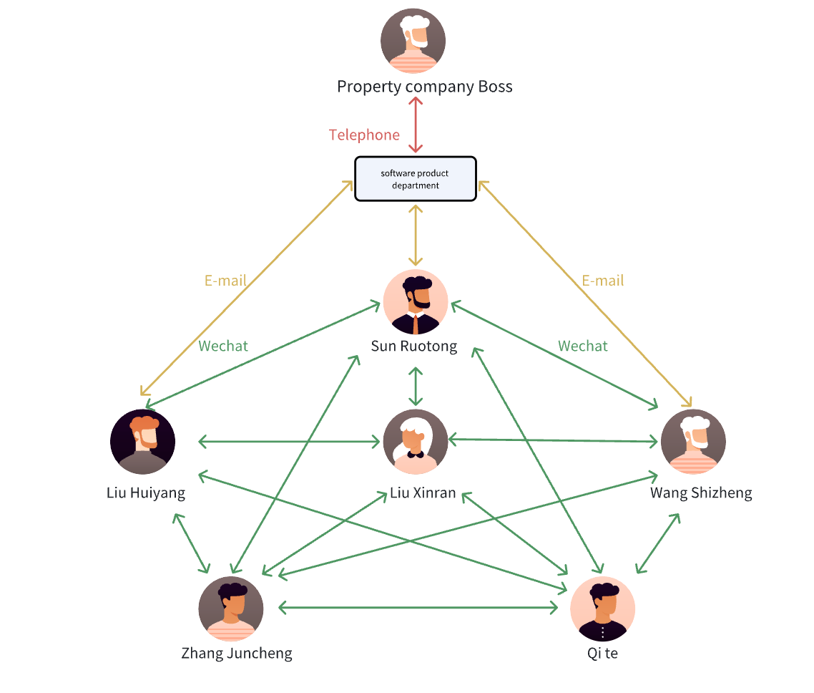

|  |  |  |  |  |
| --- | --- | --- | --- | --- |
| Type of Communication | Communication Schedule | Communication Mechanism | Initiator | Recipient |
| Weekly Status Meetings | Every Wednesday afternoon | Offline in Fourth teaching building | Project supervisor (TA) | Project Team and TA |
| Milestone Review Meetings | Every milestone finish | Offline in Fourth teaching building | Project Manager | Project Team and TA |
| Ad-hoc Meetings | As needed | Online in Tencent Meeting | Project Manager | Project Team |
| Daily communication | As needed | Email and Wechat | Project Team Member | Project Team |

# Risk Management

The Risk Management Plan outlines the approach for identifying, analyzing, responding to, and monitoring risks associated with the Sustainable Smart Community 2024 project. This plan aims to increase the likelihood and impact of positive events while minimizing the likelihood and impact of adverse events.

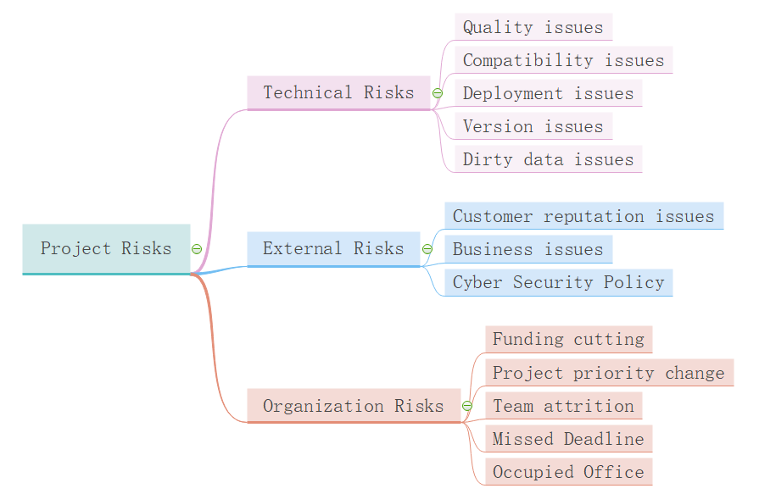

## Risk Management Plan

### Methodology

(1) Some of the methods, tools and data sources that will be used for risk management of projects

as shown as following:

1. Risk Register: A detailed risk register will be maintained to document identified risks, their causes, potential impacts, and mitigation strategies.

2. Tools: Risk management will be conducted using standard project management tools like WPS and expert consultations.

3. Data Sources: Information from clients and project team members will be utilized to identify and assess risks.

### Roles And Responsibilities

1. Project Manager: Leads the risk management process, ensures risks are identified and assessed, and oversees the implementation of risk responses.

2. Risk Management Team: Includes team leaders and other key stakeholders who assist in risk identification and mitigation activities.

3. Development Team Leader: Responsible for reporting major bugs or technical issues to the project manager for timely resolution.

### Budgeting

1. Funds will be allocated for risk management activities, including contingency reserves to address potential risks.

2. Regular reviews and adjustments will be made to ensure sufficient funds are available for addressing emerging risks.

### Time Management

1. Risk management activities will be integrated into the regular project schedule with weekly risk assessment meetings.

2. Key risks will be reviewed during major project milestones and phase transitions.

### Risk Categories

1. Technical Risks: Issues related to system performance, technology failures, and software bugs.

2. External Risks: Changes in regulatory environment, market conditions, and environmental factors.

3. Organizational Risks: Internal changes such as team member turnover, management changes, and shifts in organizational priorities.

## Risk Identification

|  |  |  |
| --- | --- | --- |
| **Identified Risks** | **Potential Responses** | **Root Cause** |
| Key supplier goes bankrupt | Find alternative suppliers, diversify supply sources | Over-reliance on a single supplier |
| Technology fails during deployment | Conduct thorough testing, have a backup system | Insufficient testing and contingency planning |
| Regulatory changes impact project | Monitor regulatory environment, adjust project scope accordingly | Lack of awareness of regulatory landscape |
| Client changes requirements mid-project | Regularly review and document requirements, maintain flexibility in scope | Poor communication and requirement management |
| Data breach occurs | Implement strong security measures, have a response plan in place | Inadequate data security protocols |

## Risk Analysis

|  |  |  |  |
| --- | --- | --- | --- |
| **Identified Risks** | **Category** | **Priority** | **Urgency** |
| Key supplier goes bankrupt | Supplier | High | High |
| Technology fails during deployment | Technical | Medium | High |
| Regulatory changes impact project | Legal | Medium | Medium |
| Client changes requirements mid-project | Scope | High | Medium |
| Data breach occurs | Security | High | High |

### Sensitive Analysis

|  |  |  |
| --- | --- | --- |
| Identified Risks | Probability | Impact |
| Key supplier goes bankrupt | 5% | Project delay and additional cost to find new suppliers |
| Technology fails during deployment | 10% | Delay in project timeline, cost of fixing issues |
| Regulatory changes impact project | 15% | Need to adjust project scope, potential fines |
| Client changes requirements mid-project | 20% | Increased project cost, extended timeline |
| Data breach occurs | 5% | Legal penalties, loss of client trust, additional security measures |

## Risk Control

### Risk Reassessment

We will conduct weekly meetings to reassess the project. These meetings aim to review all project information and identify any new or evolving risks.

### Variance and Trend Analysis

By closely monitoring the sales and revenue trends of our client, we aim to detect and address any financial anomalies or incidents early.

### Reserve Analysis

Weekly budget reviews will be conducted to ensure we have reserved sufficient funds and time to address unforeseen risks.

### Risk Audits

Our sponsors, Dr. Catherine Mooney, will provide oversight and guidance to ensure effective risk management throughout the project.

# References

The following documents are attached to this Project Plan for immediate reference.

|  |  |  |  |
| --- | --- | --- | --- |
| **Appendix** | **Document Name** | **E-DRM # /Version** | **Date** |
| A |  |  |  |
| B |  |  |  |
| C |  |  |  |
| Etc |  |  |  |